Functional Requirements Document (FRD)

Car Recolor Studio

1. Introduction

1.1 Overview
Car Recolor Studio is a web-based application that enables users to visualize different colors on vehicle images. The system provides functionality to browse and search vehicles, apply predefined or custom colors, preview recolored images, manage vehicle records, and maintain vehicle-specific descriptive content.
This document defines the functional and non-functional requirements for the application and serves as a reference for development, testing, and stakeholder review.

1.2 Document Purpose
The purpose of this document is to define the business requirements, functional behavior, data requirements, and system constraints for the Car Recolor Studio application.

2. Purpose
The primary objective of the application is to provide an interactive vehicle color visualization platform that allows users to:
- Search and select vehicle models.
- Apply colors from a predefined color library.
- Apply custom HEX color values.
- Preview recolored vehicle images instantly.
- Compare original and recolored images.
- Add and maintain vehicle information.
- Upload and replace vehicle images.
- Create and manage vehicle-specific descriptive content.

3. Scope

3.1 In Scope
The following functionality is included in the current release:
- Vehicle catalog management.
- Vehicle search and selection.
- Color library management.
- Custom HEX color support.
- Vehicle recoloring preview.
- Before/After image comparison.
- Download recolored images.
- Add new vehicle records.
- Update vehicle images.
- Maintain vehicle descriptive content.
- Reorder vehicle content sections.

3.2 Out of Scope
The following functionality is not included in the current release:
- User authentication and authorization.
- Role-based access control.
- Cloud storage integration.
- External image hosting services.
- Database implementation.
- Enterprise workflow management.
- Audit logging and approval processes.

4. Stakeholders and User Roles

End User
Users who interact with the application to:
- Browse vehicles.
- Search vehicles.
- Apply colors.
- Preview recolored images.
- Download generated results.
- View vehicle information.

Content Administrator
Users responsible for:
- Adding vehicles.
- Updating vehicle images.
- Managing vehicle descriptive content.
- Organizing content sections.
At present, both user types access the same interface since authentication is not implemented.

5. System Overview

Frontend Layer
Provides user interaction and presentation capabilities including:
- Vehicle selection.
- Color selection.
- Image preview.
- Content management.
- Search functionality.
Technologies:
- HTML
- CSS
- JavaScript

Backend Layer
Provides business logic and API services for:
- Vehicle management.
- Color management.
- Recoloring operations.
- Content management.
Technology:
- ASP.NET Core (.NET 10)

Storage Layer
Application data is stored using:
- JSON files
- Static image files
Storage locations:
- Vehicle data
- Vehicle details data
- Color data
- Vehicle image files

6. Functional Requirements

FR-001 Load Vehicle Catalog
Description
The system shall load all available vehicle records when the application starts.
Expected Behavior
- Retrieve vehicle data.
- Populate vehicle dropdown lists.
- Display available vehicle options.
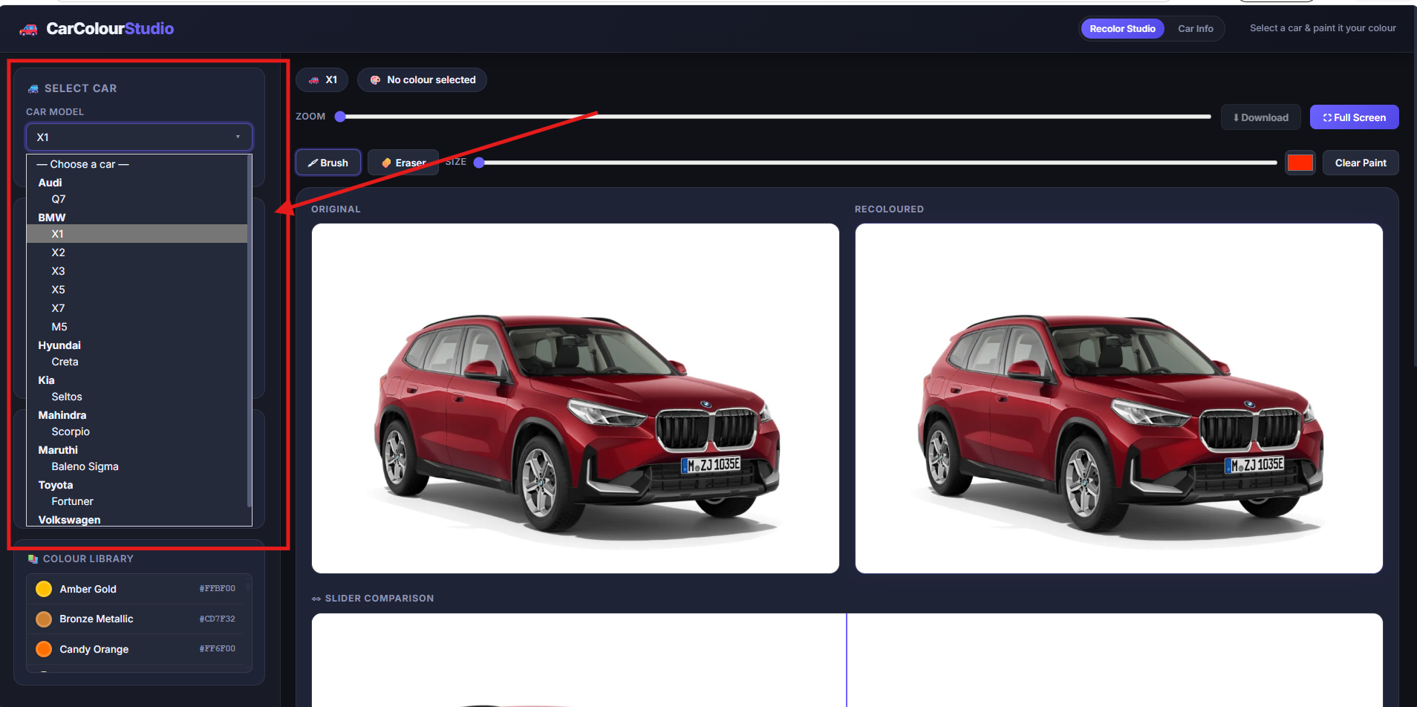

FR-002 Vehicle Search
Description
The system shall allow users to search vehicles using brand name or model name.
Expected Behavior
- Filter results dynamically.
- Display matching vehicles.
- Update search results instantly.
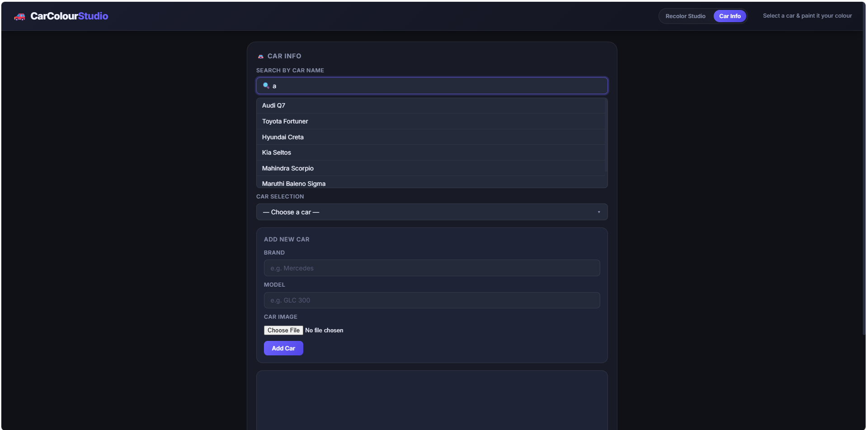

FR-003 Color Library and Filtering
Description
The system shall provide a searchable color library.
Expected Behavior
- Search by color name.
- Search by HEX value.
- Filter by category.
- Display color preview swatches.
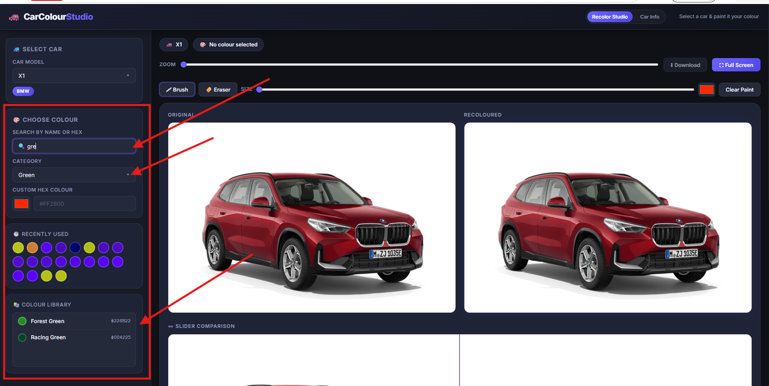

FR-004 Custom HEX Color Support
Description
Users shall be able to provide a custom HEX color value.
Expected Behavior
- Validate HEX format.
- Apply selected color.
- Update preview immediately.
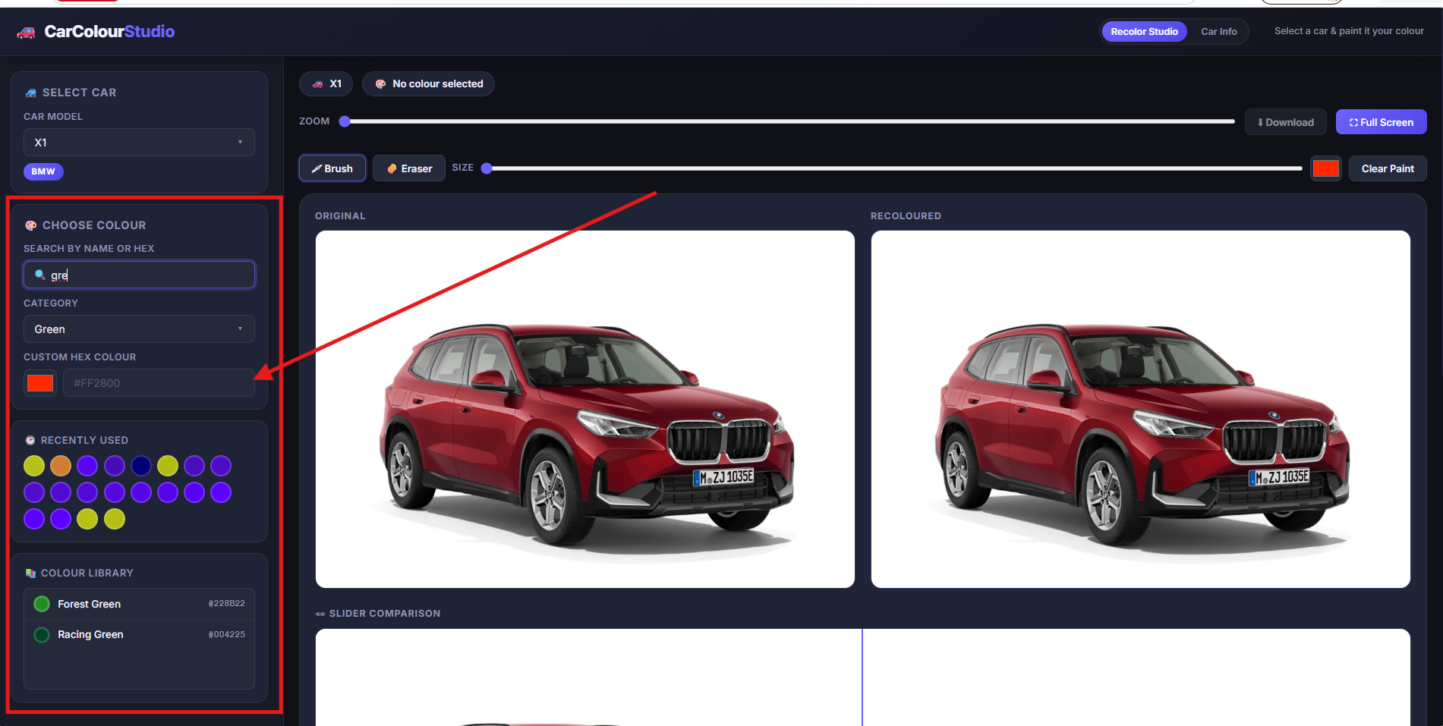

FR-005 Vehicle Recoloring
Description
The system shall recolor the selected vehicle image using the selected color.
Expected Behavior
- Send image and color information to recoloring service.
- Generate recolored image.
- Display recolored output.
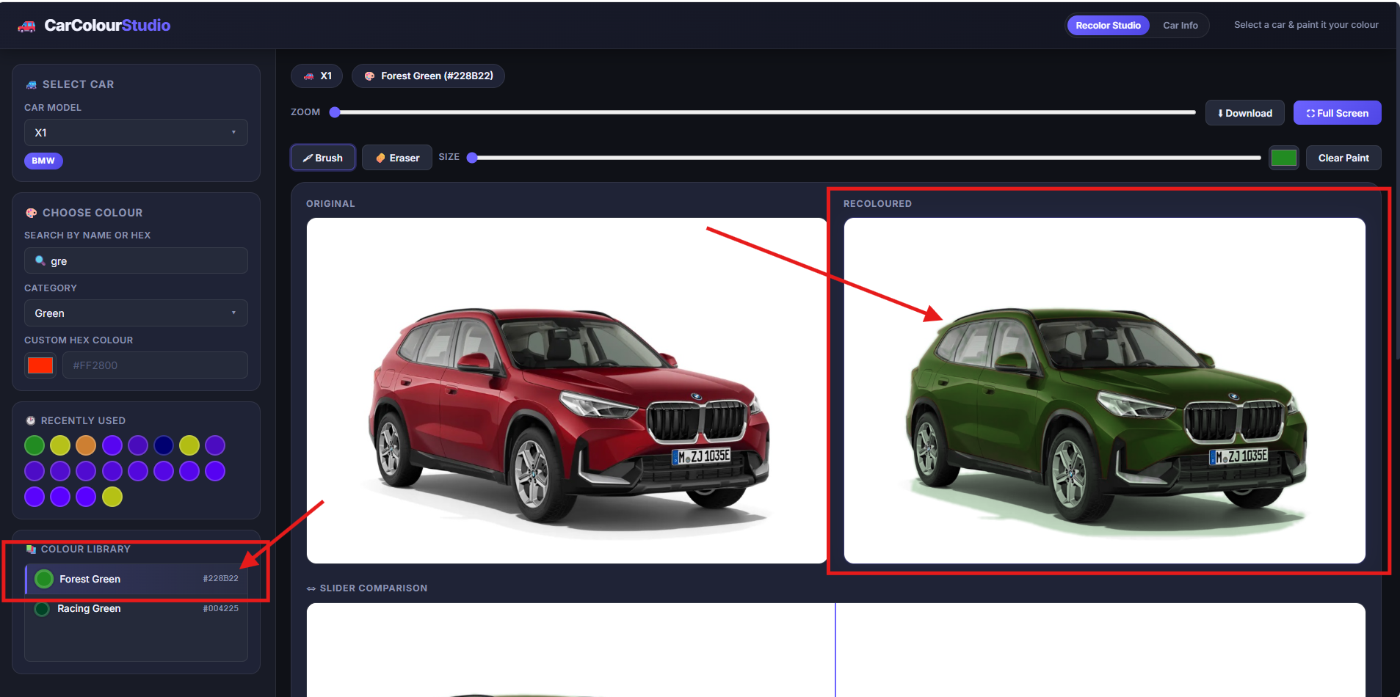

FR-006 Before and After Comparison
Description
The system shall provide image comparison functionality.
Expected Behavior
- Side-by-side comparison.
- Slider-based comparison.
- Real-time preview updates.
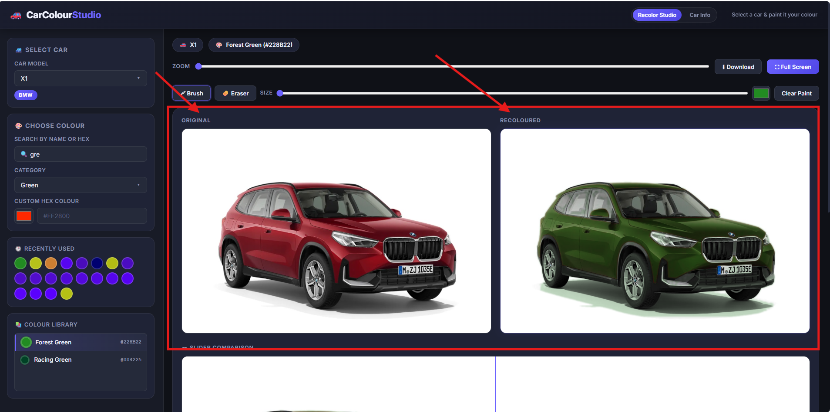

FR-007 Download Recolored Image
Description
Users shall be able to download generated images.
Expected Behavior
- Export recolored image.
- Use meaningful file names.
- Preserve image quality.
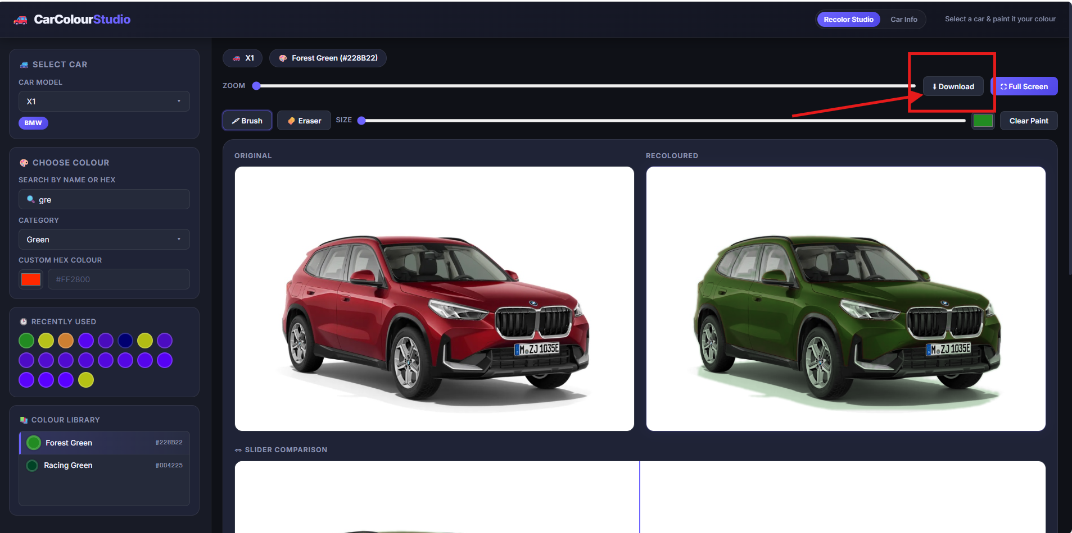

FR-008 Add New Vehicle
Description
Users shall be able to add a new vehicle record.
Input Fields
- Brand
- Model
- Vehicle Image
Expected Behavior
- Upload image.
- Store image.
- Create vehicle record.
- Update vehicle catalog.
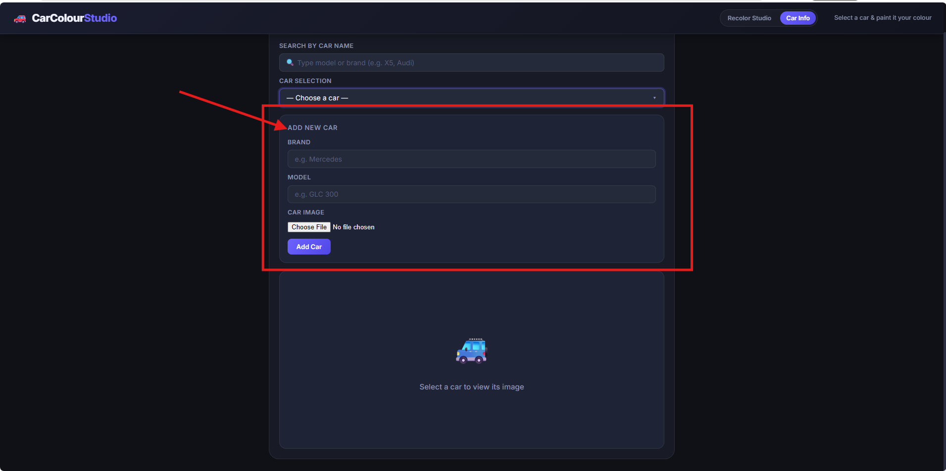

FR-009 Update Vehicle Image
Description
Users shall be able to replace the image of an existing vehicle.
Expected Behavior
- Upload replacement image.
- Update image reference.
- Remove previous image after successful upload.
- Refresh vehicle preview.
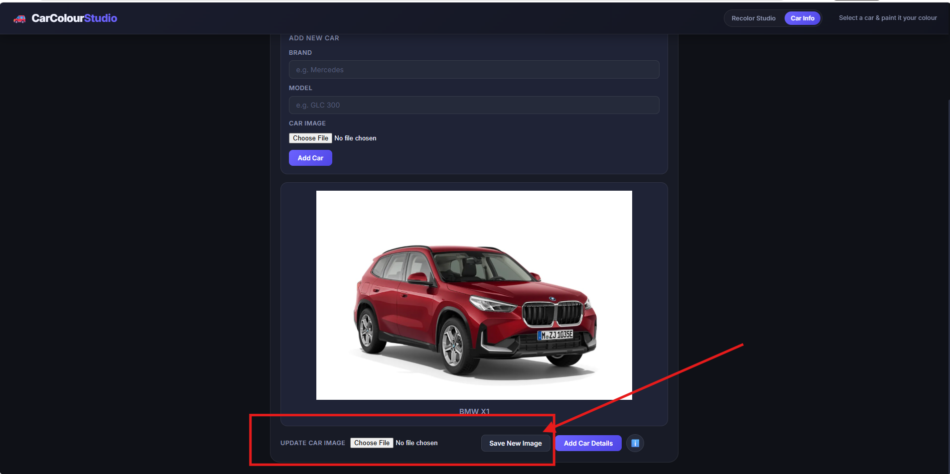

FR-010 Add Vehicle Details
Description
Users shall be able to create descriptive content for a vehicle.
Fields
- Heading
- Description
- Font Style
Expected Behavior
- Associate content with selected vehicle.
- Store detail sections.
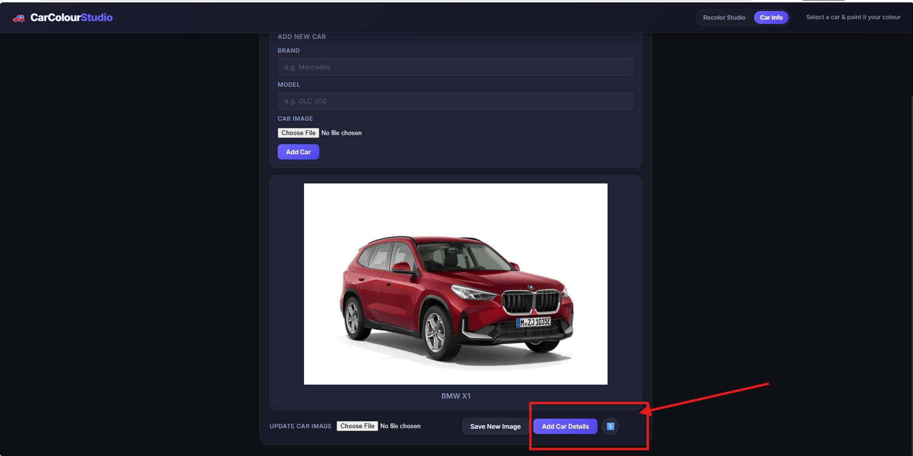

FR-011 Reorder Vehicle Details
Description
Users shall be able to rearrange detail sections.
Expected Behavior
- Drag and drop support.
- Persist display order.
- Reflect updated sequence during preview.
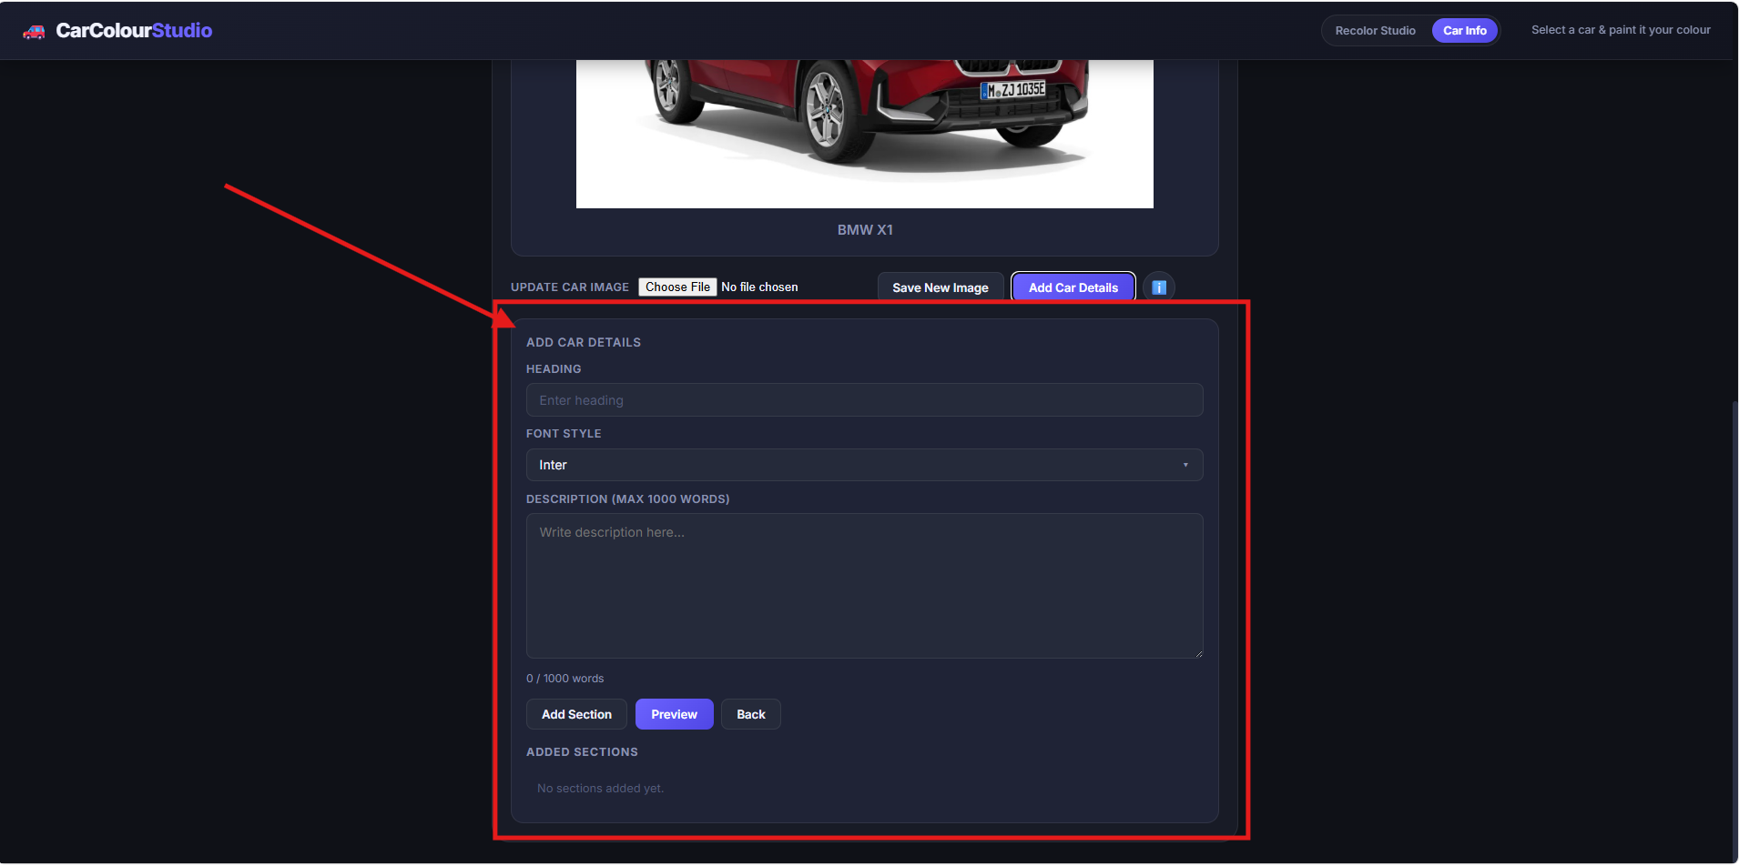

FR-012 Save and View Vehicle Details
Description
The system shall persist and retrieve vehicle detail content.
Expected Behavior
- Save content sections.
- Load saved content.
- Display associated vehicle information.
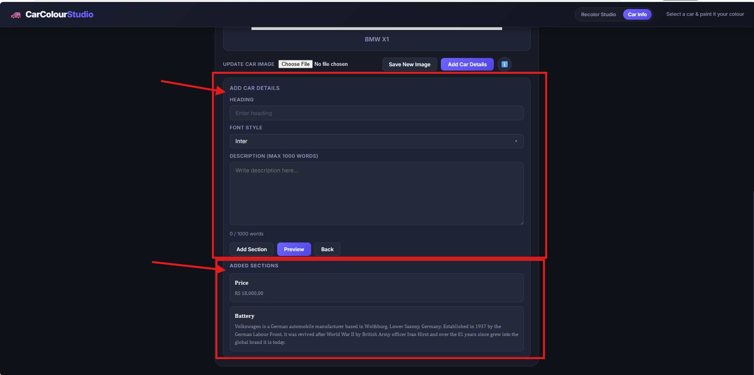

7. Business Rules
The following rules shall be enforced:
- Vehicle ID must be unique.
- Brand name is mandatory.
- Model name is mandatory.
- Vehicle image is mandatory when creating a vehicle.
- Only supported image formats may be uploaded.
- Invalid HEX values shall be rejected.
- Vehicle detail headings are required.
- Old vehicle images shall be deleted only after successful replacement.
- Content order shall be preserved after saving.

8. Data Requirements

Vehicle Entity
Field | Description
Id | Unique Identifier
Brand | Vehicle Brand
Model | Vehicle Model
ImagePath | Vehicle Image Location

Color Entity
Field | Description
Name | Color Name
Hex | HEX Value
Category | Color Category

Vehicle Detail Section
Field | Description
Heading | Section Title
Description | Section Content
FontStyle | Display Style
DisplayOrder | Section Position

9. API Requirements

Vehicle APIs
GET /api/cars
GET /api/cars/search
POST /api/cars
PUT /api/cars/{id}/image

Color APIs
GET /api/colors

Recolor APIs
POST /api/recolor

Vehicle Details APIs
GET /api/car-details/{carId}
POST /api/car-details/{carId}
PUT /api/car-details/{carId}

10. Non-Functional Requirements

Performance
- Vehicle search response within 1 second.
- Color filtering response within 1 second.
- Recolor preview generation within 3 seconds.

Reliability
- Prevent data corruption during file updates.
- Ensure image replacement operations complete successfully.

Usability
- Simple user interface.
- Responsive design.
- Easy navigation.

Maintainability
- Modular architecture.
- Clear separation of concerns.
- Reusable service components.

Compatibility
- .NET 10
- Modern desktop browsers

11. Assumptions and Constraints

Assumptions
- JSON storage is sufficient for current usage.
- Users have access to supported browsers.
- Image files are stored locally.

Constraints
- No relational database.
- No authentication system.
- Limited-scale deployment environment.

12. Out of Scope
The following features are intentionally excluded:
- User management.
- Authentication and authorization.
- Cloud storage integration.
- Enterprise workflow approvals.
- Notification services.
- Multi-tenant architecture.
- Analytics dashboards.

13. Acceptance Criteria
The solution shall be considered complete when:
- Vehicle catalog loads successfully.
- Vehicle search functions correctly.
- Colors can be searched and selected.
- Custom HEX colors are supported.
- Recoloring functionality works correctly.
- Before/After comparison functions correctly.
- Users can download recolored images.
- Users can add new vehicles.
- Users can update vehicle images.
- Previous images are removed after successful replacement.
- Vehicle detail content can be created and reordered.
- Vehicle detail content can be saved and retrieved.
- Application builds and runs successfully.

14. Sign-Off
Role | Name | Signature | Date
Product Owner | JOJO GEORGE |  | 11-06-2026
Business Stakeholder | JOJO GEORGE |  | 11-06-2026
Engineering Lead | JOJO GEORGE |  | 11-06-2026
QA Representative | JOJO GEORGE |  | 11-06-2026
Approval of this document confirms agreement on the scope, requirements, and expected behavior of the Car Recolor Studio application.

